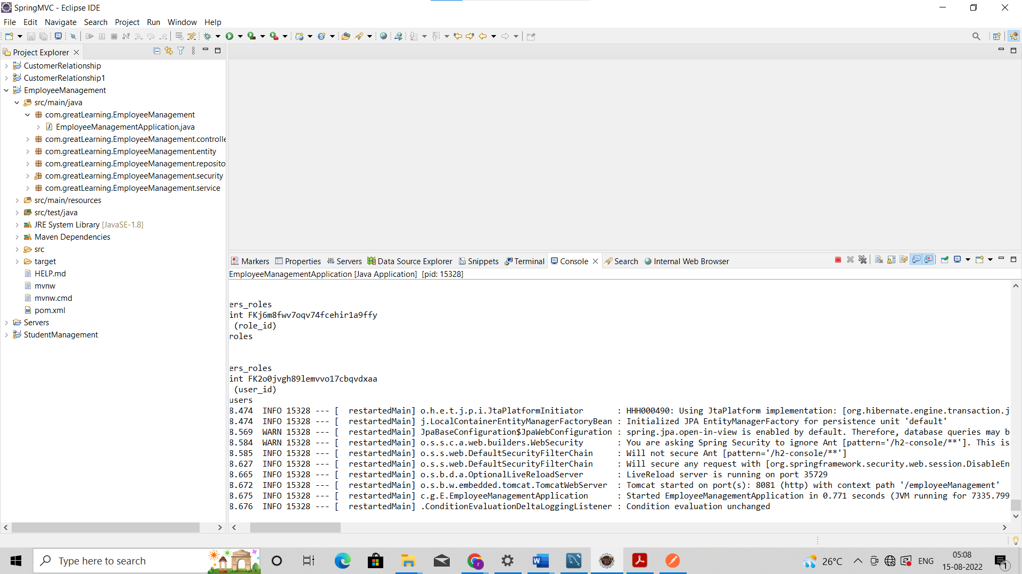

Application started on port 8081 successfully.

Logging in with default admin user

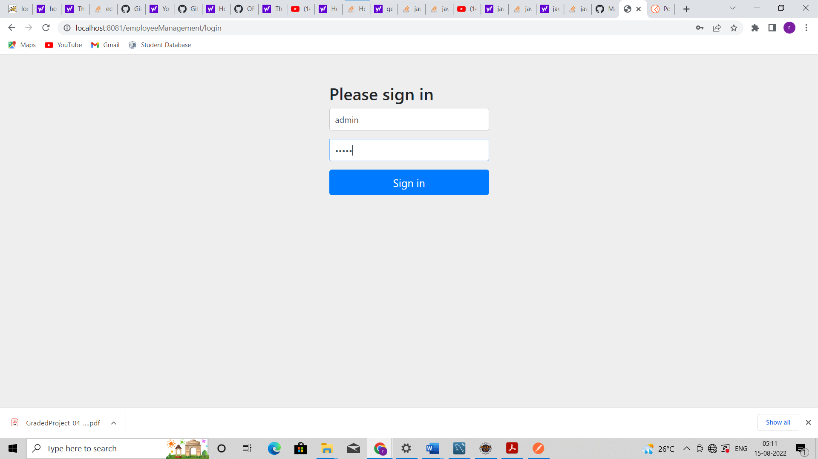

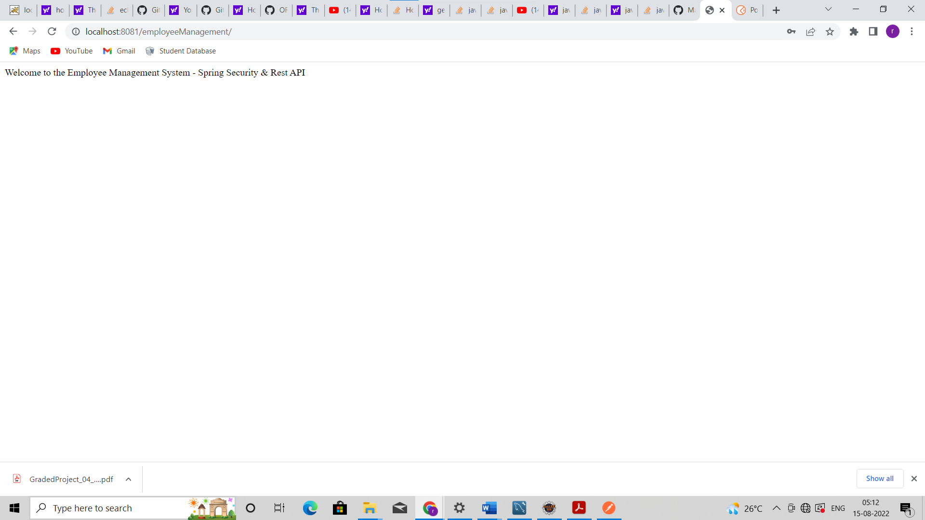

Default User data

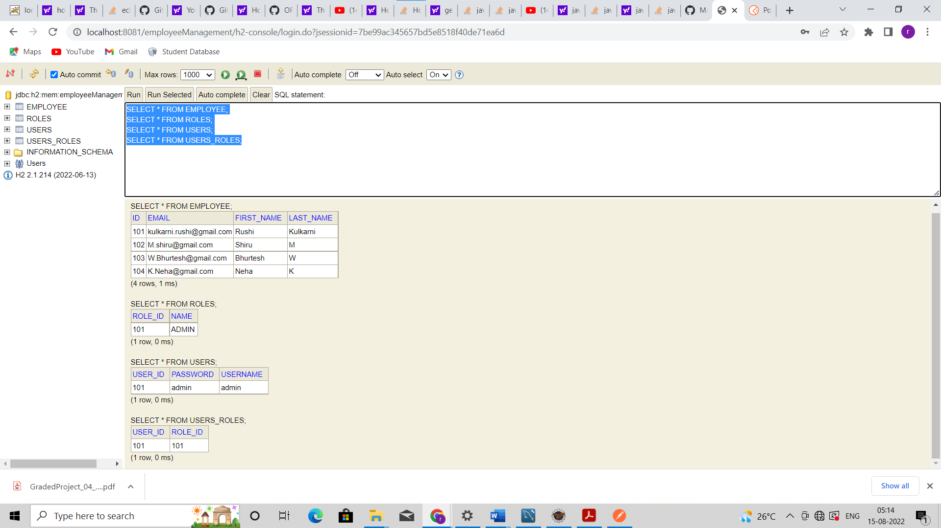

Postman login with default admin creds

Added role USER

New Role reflected in H2 console

New User Added through Postman

User Reflected in H2 console

Employee CRUD operations using admin login

Get list of all employees

Adding new Employee with admin login

New User Reflected in H2 console

Adding Multiple Employees At a time

Multiple Employees reflected in H2 console

Fetching Existing Employee By id

Updating Existing Record by ID

Update Reflected in H2 console

Deleting Existing Employee by Id

Delete reflected in H2 console

Search Record using first name

Employees sorted by first Name – ascending

Sorted by descending order

Login using Role User-

Getting 403 error while adding employee

